Instructions for Installing and Collecting Data using Wockets

PC Installation
- You need to install on each PC, the Wockets Tools (WocketsTools.msi). Copy the installer to all the PCs that you will be using in the data collection and install it (including the Oxycon PC).
- The software includes 4 different applications:
  - Wockets Data Merger: This application allows you to merge data from multiple sensors including MITes, Wockets, Zyphyr, Sensewear, Omron, GPS Data, Oxycon etc.
  - Wockets Data Viewer: This application allows you to visualize the data that you collected from the sensors.
  - Wockets Time Synchronizer: This application allows you to synchronize the clocks on different PCs with an Internet Time Server.
  - Wockets Audio Annotator: This application allows you to convert voice annotation files into an XML annotation file that can then be used by the Data Merger and Viewer.
- In addition, the software includes a pdf document with detailed instructions on how to run the Wockets software.

Phone Installation
- Copy the Wockets Phone Software (WocketsInstaller.cab) to any folder on your phone. Once the “cab” file is saved in your phone. Double click on it to launch the installer.
- If a previous version of the software is detected, the installer will launch 2 questions. The first question will ask you if you want to remove the previous version of the software, click “OK”. The second question will ask your consent about deleting the files corresponding to the previous software version, click “Yes”. If it fails to remove the application, it may ask you to install the new application any ways, click “Yes”.
- You will be prompted to install the software on your device (/) or the storage card. Choose the “device” and complete the installation process.
- You will see a message once the installation is complete.
Steps Before Data Collection
- Check Power Settings on the Phone
  - Click on the start menu. Go to Settings.
  - Choose Power
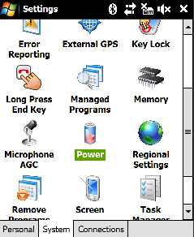

  - Under Advanced settings, uncheck Turn off device if not used for both external and battery power. Check turn off backlight for both external and battery power
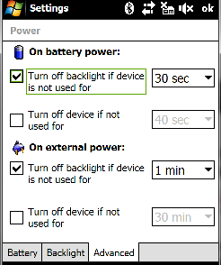

- Check Power Settings on the PC
- In your control panel, go to power settings.
- Make sure that your PC stays on, when the lid is closed and when on battery power. The kind of options that you see varies from one PC to another.
- Synchronize PC Clocks
- For each of the PCs involved in the data collection (e.g. Oxycon PC, MITes PC), you need to synchronize their clocks over the internet with a nearby time server. This is done by executing on each PC, the Wockets Time Synchronizer application.
- It is recommended that you execute the application at the same time and before each test.
- Once you have done that visually check if there is any drift between the clocks of the PCs. If they are within 1-2 seconds, no further action is required. Otherwise, try to synchronize them again.
- Synchronize Mobile Clock
  - Microsoft ActiveSync will synchronize the phone’s clock when it is connected to the PC, as long as the proper options are selected.
  - In ActiveSync, click on “Tools” -> ”Options…” In the “Options” tab, click on “Settings”. Make sure that the box next to “Synchronize Pocket PC date and time upon connecting” is checked.
  - Again, visually inspect the phone and the PC, if they are within 1-2 seconds, no further action is required. Otherwise, try to synchronize them again.
- Charge All Devices
- Make sure all devices are fully charged including the phone, the wockets, laptops etc. When not using the wockets, keep the hooked to the USB hub.
- In the current version of the Wockets, the firmware does not measure the battery charge. In the mean time, make sure the Wockets are charged for at least 5 hours before using them for a data collection session.
- Turn On The Wockets
- By default the Wockets go to sleep mode when they are not used. Therefore, before running the software, make sure you wake them up.
- To wake them up, press the “Reset” button once. The “Reset” button is the tiny black button located at the edge of the board near to the micro-usb power connector (see figure). Make sure you press the “Reset” button which is towards the edge of the board. Please note there is a second button above the reset button that shuts down the wocket.

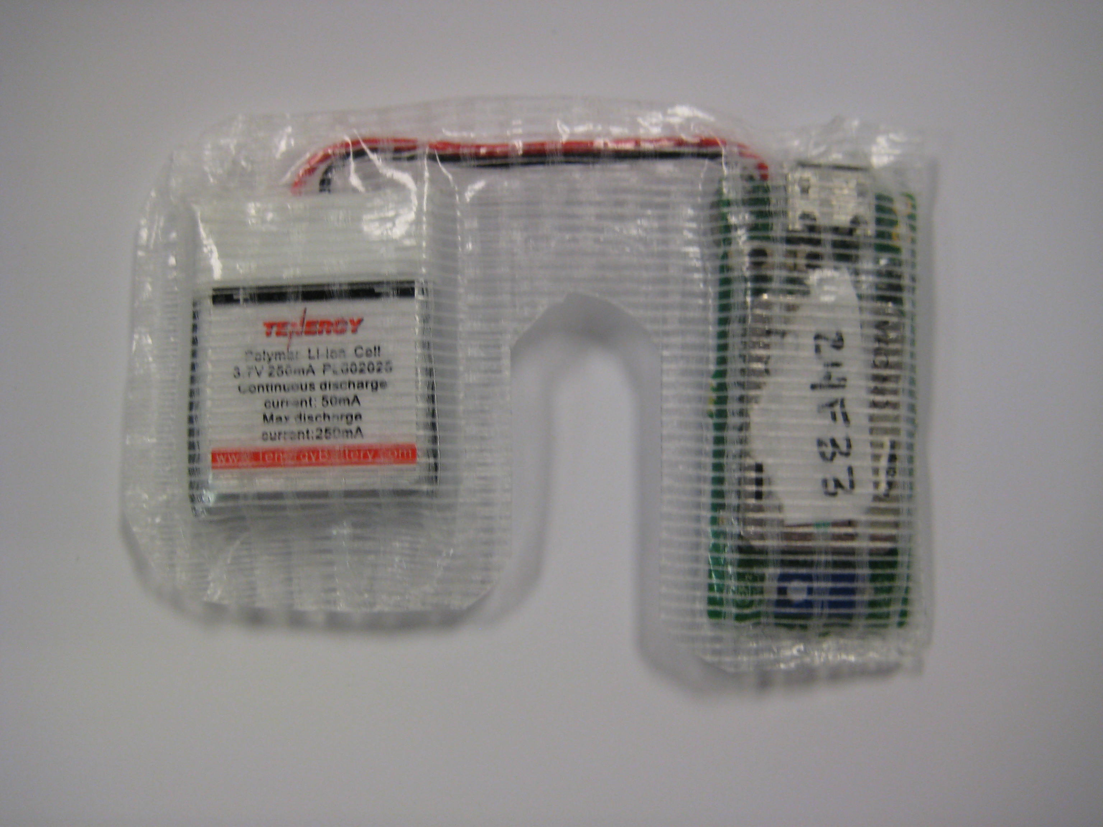
Reset Button

- After the “Reset” is pressed, a yellow light will flash every 5 seconds indicating that the Wocket is “on” and waiting to establish a connection.

Data Collection Procedures
Wockets
- The phone installer stores the wockets data collection program at /Program Files/Wockets/. Click on the start Menu>Programs then choose File Explorer.
- Navigate to /Program Files/Wockets/
- Click on WocketsApplication. This will popup the following window
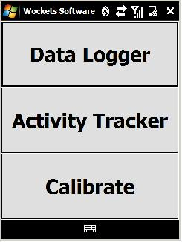
- Click on “Data Logger.” You will then be brought to this screen
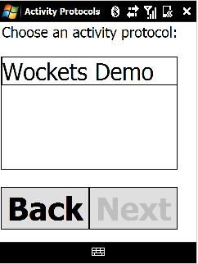

- This screen lists different activity protocols for annotation purposes. This feature is disabled in the software since you will be using the voice annotation tool. Choose any option. Then click next. This pops up:
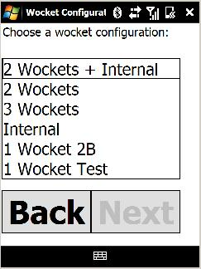
- Here you should select the sensor configuration that you will be using and then click “Next.” Select Stanford 2-wockets+internal to run with 2 wockets and an internal accelerometer. Select Stanford 5-wockets+internal to run with 5 wockets and an internal accelerometer.
- At this point, there will be several progress screens as the software is initialized and the sensors are connected. Once initialization has completed, data collection will begin and the screen should look something like this:
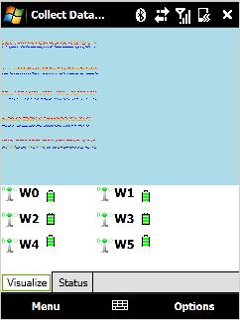

- It should be noted that as you start the software, plotting might be slower than usual or a wocket might briefly disconnect the reconnect. While this is rare, it might happen depending on the configuration and the environment you are in.
- While running the program, you have several controls available. Clicking on “Menu” will give you the option to quit or minimize the application. Clicking on “Options” provides, among other things, the option to turn plotting on and off. We recommend turning plotting off as it makes the application less computationally intensive and allows it to run more smoothly. Clicking on the “Status” tab, gives you a periodic readout of the function of the sensors (this will initially be all question marks until the first update).
- We recommend the following steps before giving the subject the phone:
  - Turn off plotting by unchecking it on the options menu.
  - Minimize the application
  - Lock the screen by clicking the right phone button
  - Ideally the phone should be placed on the front side of the body
  - Write down the time in which your data collection starts. The data collection “start date” and “start time” is used to generate the folder name in which the wockets data is stored at the end of the session.
- Once the data session is completed, you can maximize the application by following these steps:
  - Unlock the phone
  - Click on the start Menu>Programs then choose Wockets.
  - The Wockets Application will be maximized.
  - Choose Quit from the left Menu and wait until the application terminates.
  - Your data will be stored in a folder on your storage card under /Internal Storage/Wockets/. The folder is named Session<date><time>. Copy that folder to your PC, zip it and send it to us.

Oxycon
- After turning on the device and waiting for the system warm-up in Lab Manager run an automatic volume calibration test and save the results.

- In the Report Designer application in Utilities open the report template you want to use for the test results. Double click on the box containing the data elements to be printed.
  - It's important to make sure that Time, Energy expend, O2 uptake, and CO2 production are included in the elements printed in the report. If they aren't in the Selection box find them in Parameters and insert them. If the Insert button can't be clicked delete some of the elements in Selection until the necessary elements can be inserted.
  - Go over to the Interval tab and change the averaging type to Breath Averaging and the Step Size to 1. Save and exit.

- In the Startup settings box for the Breath x Breath test, go to the averaging box and set the Method to Time and the Delta time to 5. Combined with the report settings these produce the most accurate results.

- Run the test and save. Make sure when saving, always save to a new test. This is usually the default setting but you can check it by clicking Advanced. Before you save the flash data test open up the disk in Window's Explorer and check the properties of the CPX file. The Modified time corresponds to when the test ended (the last press of F1). Make sure to copy over the CPX file into another directory and preferably name it in a manner that makes it easy to match it up with whatever test it refers to. Save the flash data test and exit.

- Now go into patient data and load the current patient. On the bottom pane click Reset to remove all the tests from the right hand table. In the test directory the last 2 entries should correspond to the PC saved data and the flash disk data, respectively, saved as 2 different tests. However, the flash data might not be the test right after the PC data if you've run and saved multiple tests without saving any of the flash data. It might be easier to keep track of, if you save the flash data immediately after running a test. Click the right arrow to select that test to be output by the report. Only output 1 test at a time (meaning reset after printing a report).

- Generate the output files, save them and send them along with the raw oxycon data files from the PC and from the flash (including CPX file) to MIT.

Data Merging and Visualization
- Create a directory on your desktop to store the data.
- Copy the MITes data into this directory.
- Create within this directory a wockets directory
- Copy the wockets data into the wockets directory.
- Copy any additional sensor files into the MITes directory (e.g. oxycon files) using the following conventions:
COPY FROM OLD DOCUMENT
- Run the data merger software. A window will popup that allows you to select a directory. Choose the directory that you created.
- Start the merge process.
- Once the merge process is completed. You will be prompted to Quit. Quit the program.
- The software now created a merged file for all your sensors in the directory that you created.
- Start the Wockets Visualizer. Choose from the File Menu, open. Open the folder that you created. This will load the data in the visualizer.

Voice Annotation Tool
- Run the application by double clicking the AudioAnnotation.exe

- Once the application is running. Provide a valid directory path where your audio files (.wav and .msv) are located. The program expects to see both types of files in the same location. Besides, it also expects that the number of files .wav and .msv match. If the files number doesn’t match, the program will continue running but it will send a warning message.

- If the files are loaded successfully, you will see the following screen:

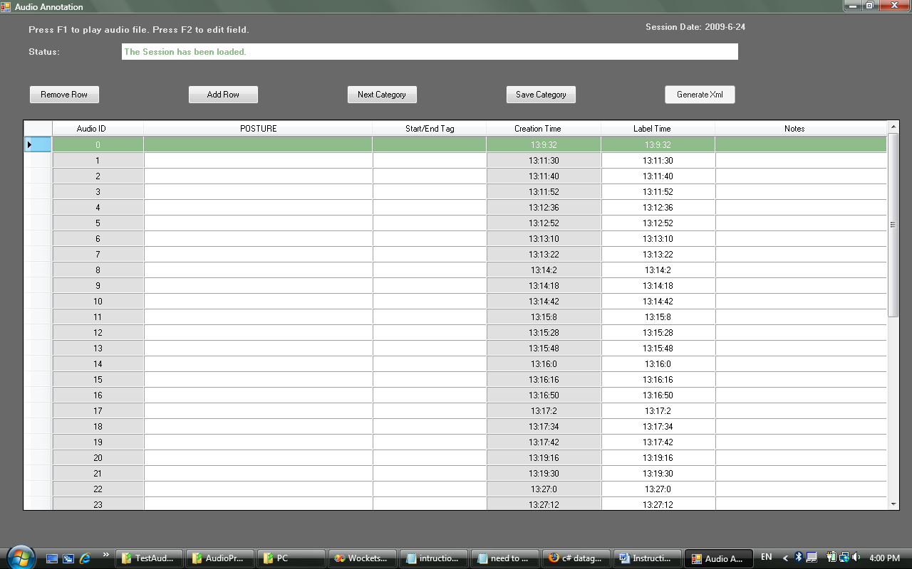
- The program creates an annotation field for each file found in the audio. Then, as a sanity check, see that the number of rows and the number of files matches.

- The program highlights in “green” the row that is currently selected.

- When a row is selected, a “play audio button” contained in the first column will be highlighted. You can click the “play audio button” to listen to the corresponding audio files. To avoid confusion, only one file can be played at the time. Thus, the program disables the other table fields when a file is being played.

- Another way to play the audio file is pressing the “F1” key.

- The other table columns contain the annotation information. The columns with cells in “white” means that the column fields are editable. The column with cells in “gray” means that the fields are not editable. The file ID number and the file creation time are not editable.

- The annotation information corresponding to each column can be described as follows:

Column Number | Name | Functionality
1 | Play button | Plays the audio file associated with the current row.
2 | Audio ID | Indicates the ID of the audio file.  When a row is being added, the row will not have a file association. In such case, the row ID will be empty (“-----”).  This field is not editable.
3 | Category Field | It is a dropdown menu containing the entries set up for Posture/Activity categories. This information is loaded from the ActivityLabelsRealtime.xml file. Hence, you can modify the labels appearing in the dropdown menu by customizing the category entries in the file.
4 | Start/End Field | It sets the Start/End labels. In general, the program will try to complete these entries automatically according with the category labels you have selected.  However, if you find a mistake, you can always overwrite the value suggested.
5 | Creation Time | “Hour : Minute : Second”  This field indicates the time when the audio file was created. Make sure these values matches the times you expect. Specially, pay attention to the seconds entry.  This field is not editable.
6 | Label Time | “Hour : Minute : Second”  This field indicates the time that will be used in the output Wockets annotation file. In general, this time will be similar to the creation time. However, if you need to adjust this field you can edit the entry.
7 | Notes | You can write any notes you need. This field is completely editable. Just try to avoid using “TAB” or “;” (semi-colon) keys.

- Editable Fields are accessed by just clicking with the mouse on them or pressing “F2”.

- Rows can be added by pressing the “Add Rows” button. The new row will be inserted after the row you were located. The new row will not have an associated audio file (you will see “------” in the Audio ID field). The “Label Time” field ID will correspond to the next available creation time file.

- Rows can be removed by pressing the “Remove Rows” button. The program will remove the active row (row with “green” background).

- Row can be skipped by just leaving the row without editing or filling it with blank.

- Row contents can be cleaned up by setting the category label to “blank”. (Select “blank” in the “category label” field using the combo box.

- The annotation values for each pass can be saved by pressing the “Save Category” button.

- The program will continue to the second pass of the annotation by pressing the “Next Category” button. This button will automatically save the current filled values.

- Once the program is in the second pass, you will see the field values associated with the second annotation category.

- The “Previous Category” will allow you to see the annotations from the first pass. You can come back from one pass to another anytime you want. The program automatically will save the category annotation values.

- The “Generate Xml” button will generate an Xml according with the information you have entered.

Trouble Shooting
  - When a wocket is disconnected, the screen will look like this:
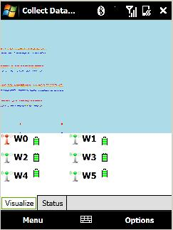
  - If plotting, the data stream from that sensor will cease. Also, the antenna image next to that wocket’s ID will turn red. Look at the disconnected wocket (you can tell which is disconnected by shaking them all a little and using the process of elimination or you can keep track of which ID corresponds to which sensor).
  - If the yellow LED is flashing, just leave it alone and it should reconnect on its own. This might take up to 20 seconds. If it does not reconnect, you might try pressing the reset button (black button with “RST” above it). If this does not cause the yellow LED to flash, the wocket is likely out of battery or broken, and it should be replaced.
  - Please let us know of the problem.

